**Virtual Design Report**

**Filament Recycler**

Group Members: Alec Rich, Connor Cassaro, Jon Bayert,

Paul Oscar Benbow, Munib Rashad, and Nicole Pomeroy

Primary Advisor: Dr. Daniel Blood

Secondary Advisor: Dr. Sami Khorbotly

Course: GE-497

Valparaiso University

Report Submitted on October 22, 2020

The goal of this project is to create a filament recycling system for student and youth groups in a non-profit application. To successfully meet the needs of the customer, the recycler needs to be able to extrude PLA within a specified diameter tolerance and have the ability to save preset extrusion settings for PLA. The system will be able to accept multiple input voltages and reach temperatures high enough to melt PLA and other commonly used filament materials. The recycler will be broken up into three subsystems: extrusion, diameter control, and spooling. It should also be noted that the system will meet OSHA and general safety standards to ensure that its operation will not endanger young learners or the user.

**Honor Code Statement**

I have neither given or received, nor have I tolerated other’s use of unauthorized aid.

*Connor Cassaro* ***Munib Rashad***

Connor Cassaro Munib Rashad

*Nicole Pomeroy*  Jon Bayert

Nicole Pomeroy Jon Bayert

*Alec Rich*  *Paul Oscar Benbow*

Alec Rich Oscar Benbow

**Table of Contents:**

Section I - Introduction: **4**

Section II - Problem Definition: **4**

Section III - System Overview: **4**

Section IV - Virtual Prototype: **5**

Manufacturing and Dimension 5

Wiring Diagrams 8

Sensors 8

Section V - Budget: **9**

Section VI - Conclusion: **9**

Figures and Tables: **10**

References **21**

Appendix A: Mechanical Drawings **22**

Appendix B: Wiring Schematic **23**

Appendix C: UI Operating Procedure **25**

## Section I - Introduction:

A filament recycler is a system that accepts shredded plastic and turns it into filament for 3D printers. The goal of the project is to create an open source filament recycler for educational purposes. The barrel will be wrapped in a wire heater to heat the barrel up to melt the plastic that is being pushed through by the screw from the hopper. It will then be forced through the die and be cooled down so that it can be respooled. Figure 1 shows a model of what the entire design should look like. The filament recycler is a way to teach kids about recycling and also help the schools and libraries keep costs down by not having to purchase new filament. This report will go into detail on all the work that has been done thus far and why it has been done for the project. The following report will lay out the problem that the design will fix, an overview of the entire system, detail what has been virtually prototyped, and go over the budget for the project.

## Section II - Problem Definition:

The reason for creating this filament recycler for the customer is that he wants to show kids that they can take their old or messed up prints and recycle them into new filament for them to use again and create more prints. The customer has requested this filament recycler because the other similar products on the market that he had been looking at cost in the range of $5,000 to $8,000. He wants something that will be educational and still cost less. Some problems include that the design must be safe for kids to be around. This means that outside surface temperatures should be limited so that anyone who comes into contact with it will not be burned. Likewise, there cannot be any moving parts exposed to prevent someone from being harmed should they reach into the system. Since this will be educational, the customer will likely be transporting the system to schools and libraries, therefore it leads to having to minimize weight and size where necessary. The biggest challenge is making sure that the filament is extruded within the tolerance of 1.75 ± 0.05 mm. If the filament comes out of tolerance, the filament will not be usable for printing and would likely be shredded and run through the extruder again.

## Section III - System Overview:

The goal of the system is to get one kilogram filament spools from ground up filament that can be used by 3D printers. The system can be divided into three major subsystems; the extrusion, the diameter control, and the spooling mechanism.

The extrusion subsystem is where the system will take ground up plastic, melt it down, extrude it into 1.75 mm filament and cool it down. Ground up recycled filament and virgin filament will be added to the system via the hopper, which will be attached on the top of the heated barrel. A screw will be in the barrel and will be attached to a DC motor with a coupler. The motor will rotate the screw and move filament towards the extrusion die. Right now the primary focus of the system is to be capable of recycling PLA. PLA melts somewhere in between 130 and 180 degrees Celsius. A cable heater will be wrapped around the barrel which will raise the temperature of the stainless steel barrel to 180 degrees Celsius. The heater will be capable of raising the temperature of the barrel to 260 degrees Celsius so that the system will be able to recycle plastics other than PLA. The ground up filament will get melted as it moves along in the heated barrel. PLA is a polymer therefore doesn’t turn into liquid once its melting point is reached and takes a viscous form. By the time groundup filament reaches the extrusion die, it will be viscous and ready to be extruded into filament.

There is a deadzone within the barrel in between the extrusion die and the screw. This dead zone will act as a small storage and help raise the pressure in the barrel. Once the dead zone is full, the pressure will build up and push viscous filament out of the extrusion die. Filament will come out of the extrusion die in the form of continuous filament strands that are expected to have a diameter of 1.75 mm. As soon as the filament leaves the extrusion die, with the help of fans (forced convection), the filament will be cooled down so it does not deforme. The extrusion is complete. Now by hand the user will move filament to the next subsystem.

The diameter control subsystem will be used to ensure that the extruded filament remains within a given tolerance range; for the die that the current design is using, this will be 1.75 ± 0.05 mm. After exiting the barrel and cooling, the filament will be put between a pair of rollers mounted on servo motors which will apply tension to the filament and pull it through the system. It will then be fed through a micrometer which will continually measure its diameter. Should the diameter fall outside of the desired tolerance range, the rollers will adjust the tension applied to the filament accordingly so that the diameter remains within the tolerance.

The final subsystem of the filament recycler is the spooling mechanism. Once the filament has passed through the micrometer, it will have to be manually attached to the spooler at the end of the system. After being attached, a servo motor will begin to rotate the spool such that the filament is wound around it. A light sensor will be present on the spool shaft to measure its speed of rotation, which will be automatically adjusted by the microcontroller to ensure that it is not turning too quickly compared to the rate of filament output. A weight sensor will be present beneath the entire subsystem to measure the weight of the filament on the spool and display it on the user interface. The spool of filament will be able to be detached and used in a 3D printer.

## Section IV - Virtual Prototype:

### Manufacturing and Dimension

**Screw and Barrel**

These components are manufactured by Precious Plastic according to the schematic shown in Figures 2 and 3. While not shown in the diagram, an uncommon threading on the end of the barrel which is not used in the end product of the filament recycler. The screw and barrel are used together to press melted plastic through an isolated system by having tight tolerances to each other and a taper on the screw.

Constraints on use of this part will involve minimizing modification of this pair of components so that the length and diameter tolerances are not altered. This pair in turn restrains the project by its threading and natural dimensions; nozzles of 1.3in diameter with ~11 threads per inch would be costly to manufacture and are not commonly sold.

**Coupler**

The Screw for this system comes standard with a hexagonal cross section that is .5in in size. To connect to the motor axle chosen for this project, a coupler will be used to accept the hexagon screw end to the desired motor output. Specifically for this project, a Leeson 1/3hp DC motor was used and the resulting coupler is displayed below in Figure 4.

This component will be constrained by material strength as high torque is applied from the motor to turn high pressure melted plastic. Size will also come into play due to the motor height off of the ground, so increasing the area will have its limitations.

**Support Plate**

This plate will hold the different processes at certain points to better keep tolerance and optimize cooling to size for the system. It will also be used to raise the screw and barrel up to the height of the motor output so that the screw and barrel are concentric around this point. This will prevent part wear from the screw scraping against the barrel.

Support plate dimensions will be constrained by the height of the Leeson motor output, barrel geometry, and cooling necessities. The plate needs to be able to hold the barrel by its premanufactured bolt holes without causing the screw to scrape along the side, as well as provide enough time for fans to cool the filament before rolling tension is applied.

**Barrel Flange and Die**

It was determined that creating an external flange and die would be best for the scope of this project due to the ease of modification, maintenance, and complexity of thread based nozzle production. This component will reduce the flow of melted plastic through a 1.75mm diameter die that is a separate component from the external end cap. The purpose is to create correctly sized filament and to have a part that if worn out would be as easy to replace as a filter. Individual parts are shown in Figures 5, 6 and 7 and can be seen assembled in Figure 1.

The flange itself is constrained by the given barrel diameter and the die must output 1.75±.05mm while fitting in the cavity between flange plates. It should also be noted that both flange plates and die components should be fairly strong to face increased temperatures and high pressure.

**Roller Assembly**

Controlling the filament diameter with immediate reaction based on a control loop would be most easily accomplished by using applied tension. The roller assembly was found to be the most adequate option for this purpose and consists of rollers, axles, and its own individual housing shown in Figure 8.

To define the assembly, the housing must put the rollers at the same height of the filament so that there is no additional tension from gravity pulling in either direction. The rollers must also be correctly spaced so that it provides a tension but does not crush the filament out of tolerance. A final consideration would be if the housing can hold a Hitech 6VDC servo motor in line with a roller axle so no angled stress is applied.

**Spooler Assembly**

The final step in this process would be to wind the extruded filament onto a standard 1kg spool. To ensure that the filament winds relatively tight and holds approximately 1kg of PLA filament, the spooler will consist of a second Hitech 6VDC servo motor that will wind the spool while sitting on a load cell force sensor that will serve as a scale. The basic concept can be seen in Figure 1 (far left) or as component 12 in figure 11 where a 1kg spool is mounted to a structure powered by a second Hitech 6VDC motor and will be placed on a scale.

The constraint will be that the servo should not be stronger than the roller servo as that would provide more tension and cause additional deformation. The spooler scale should also be able to withstand the weight of a full 1kg spool and servo motor, while still accurately reading the weight of this system.

**Motors**

Three motors are required in this filament recycling design. The first will be a Leeson 1/3hp DC motor that will handle the bulk of the torque required to push plastic through the pressurized barrel. The other two will be Hitech 6VDC servo motors and will not face nearly the load as the first and will be used for delicate filament processes after extrusion.

All three will be constrained by cost and application of a motor. Each motor must be variable to control speed and be able to meet torque requirements for PLA and with a mind towards PETG, which would require higher requirements by the customer if they choose to branch out to more plastic types.

**Insulation**

As part of the safety protocols, insulation will be applied along the length of the barrel to reduce the temperatures from as high as 300 °C down to 49 °C. For this purpose, .5in fiberglass insulation is being considered but may require additions based on testing. If the insulation fails to reduce the barrel temperature to 49 °C, a cage will surround the system so that it cannot be touched by bare skin. If other components of the system break 49 °C through conduction, more insulation will be required to cover the system.

The safety constraint for this system is that 49 °C will require several minutes to apply a burn, it would not be an accident if one got burned at this temperature [1]. However, if failure to create a system of this temperature as the system is active, a more instantaneous burn threat will be in play that could place children using the recycler at risk of injury.

**Heater**

The heater component for this project is a wire heater that would perfectly hug the outer diameter barrel and is adjustable such that it could be grouped tighter to produce more heat to the plastic. The heater will be controlled with a the Dwyer series 16B 1/16 DIN controller. The controller will be connected to a thermocouple and the heater. This will use a PID loop to precisely control the temperature of the filament. In addition, the temperature can be set from the arduino. This will communicate over modbus to the arduino using a custom shield.

Heating of the plastic is constrained by motor speed and plastic properties. It is not desirable for plastic to be too melted or it will ooze out of the extruder. Through testing, a resulting calibration relationship between screw speed and temperature will be developed, but for now a known design constraint is that PLA will melt between 130-180±2.5 °C.

**Hopper**

Plastic enters the system through the hopper, which is essentially a waiting room for plastic to sit in and wait for processing. The customer has already purchased a grinder so this system will only accept ground up or virgin plastic into the hopper.

While a hopper is a simple project, it must fit well into physical constraints, system requirements, and safety regulations. The barrel component ordered from precious plastic holds a certain angle and opening to support specific hopper openings which can be seen in Figure 9. To ensure that a full 1kg spool can be created from a load of plastic, 1 kg of plastic should be able to fit in the hopper in one fill. Lastly, as per Table O-10 of OSHA 29 CFR

1910.217(c)(2)(i)(a) and 1910.217(c)(2)(i)(b), the hopper will be equipped with a safety mesh that will allow .7mm plastic shreddings and not fingers to pass into the screw at the bottom of the hopper.

**Fans**

There will be a fan to cool down the filament after it is extruded. As soon as the filament exits the system, there will be a fan to help cool and shrink the filament so that it can be spooled. This can be turned on and off from the arduino.

### Wiring Diagrams

**AC to DC Converter**

There are two converters. The first converter takes 120 Volts AC or 210 Volts AC and converts it to 24 Volts. The heater uses AC voltage while the barrel motor uses 24V.

But many of the sensors use 5 volts, so there is a second converter that converts 24V to 5V. This way the arduino and other sensors can run off 5V.

**PCB Boards**

This design will have two custom pcs. (See Figure 10) The first is a shield for the arduino. This will include connections for the following components:

* MODBUS to Heater controller
* I2C to UI
* Analog signal to the Speed controller
* HAL sensor analog input
* 5V signal to the fan
* 2x Input for the photo interrupt
* 2x servo PWM outputs.

The next PCB is for the UI. This will be able to communicate with the main board over I2C. The LCD can then be moved around on the system or extended past a safety screen. This allows people to stand back out of the way and still control the system.

### Sensors

* Diameter sensor. The filament will be fed through a diameter sensor. The filament will be sandwiched between a magnet and hall effect sensor. The magnitude of the reading on the hall effect sensor will be converted to the diameter of the filament. This will then be used.
* Photo Interrupt. This design is using a photo interrupt to calculate rotations of the screw motor. Everytime the barrel rotates it will pass through the photo interrupt, the system will be able to count the number of revolutions that the barrel completes. This will also be added to the spool to measure it.
* Emergency Stop. There is a big red emergency stop button. This will cut power to the system in case there is an emergency. This is an important safety precaution and is needed in case there are any shorts.

## Section V - Budget:

The budget that was provided for this project was $5,000, but it was estimated that the entire system could be built for under $2,000. There are numerous different parts that need to be purchased to make the filament extruder system and all parts have been listed in Table 1 in the Figures and Tables section of the report. In the bill of materials, the components have been broken down into 3 categories: electrical components, structural components, and other additional components. The first category, electrical components, is by far the largest and most expensive category. The total cost of all of the electrical components is $1691.72 and well over half of this price is made up of the motor and gearbox needed to turn the screw. The next section is the structural components like the screw, barrel, and stock material needed to make the in house manufactured parts; this category costs $143.84. The final category in the bill of materials is just additional components that are needed for the design, such as the insulation and this category comes in at $36.83. The total cost of all components sums up to $1872.39.

## Section VI - Conclusion:

The goal of this project is to create a system to recycle used filament for student and youth groups in a non-profit application under a budget of $5,000. To successfully meet the needs of the customer, the recycler needs to be able to extrude PLA with a diameter tolerance of 1.75 ± 0.05mm, with the ability to save presets using a closed control loop. The system will be able to accept multiple input voltages and reach up to 260°C with a 2.5°C tolerance. The recycler will be broken up into three subsystems: extrusion, diameter control, and spooling.

The total cost of the recycler is estimated to be $1,872.39, meeting the customer’s cost requirements. The filament diameter and temperature are anticipated to meet expectations due to the reliability of the component sources and calculations. An adapter for the power input will ensure that regardless of power source used, the recycler can be simply plugged in without further problems. Safety within the recycler prevents extremities from burning and crushing using insulation and hopper precautions. The system will be open source therefore the design will be documented completely. This will make the extruder more flexible and open for modifications.

## Figures and Tables:

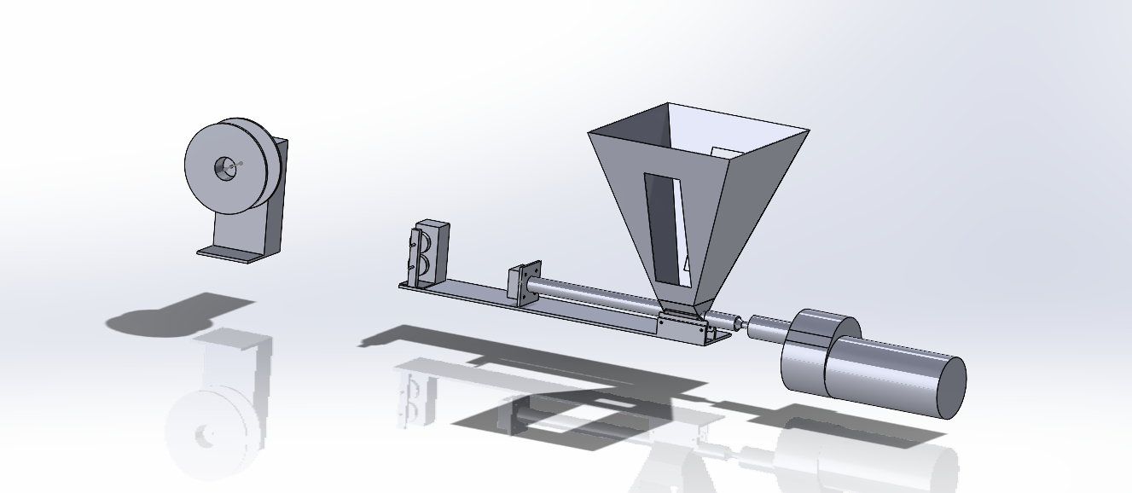

**Figure 1**. Final system assembly

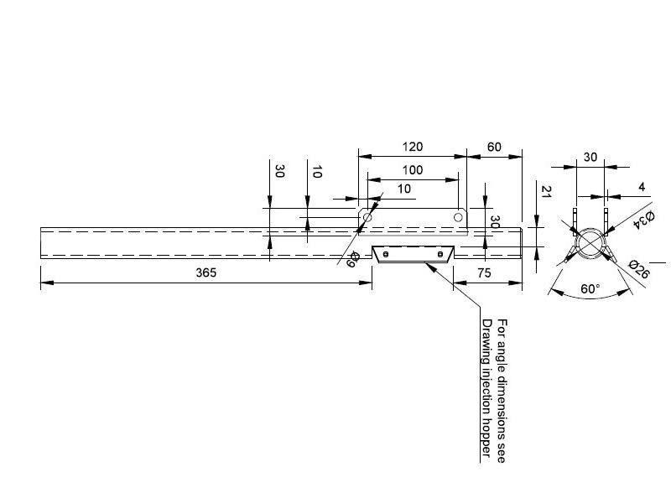

**Figure 2**. Drawing of the barrel from Precious Plastic [2]

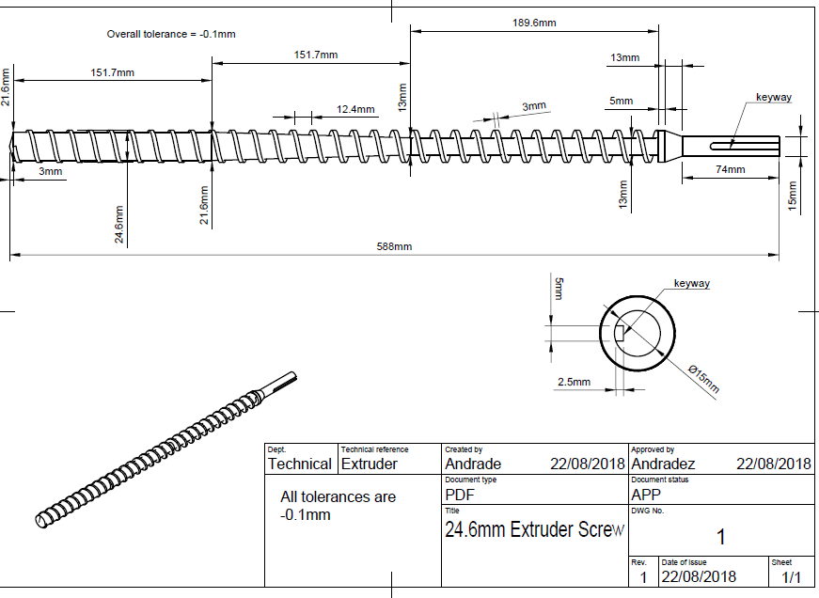

**Figure 3**. Drawing for the screw from Precious Plastic [2]

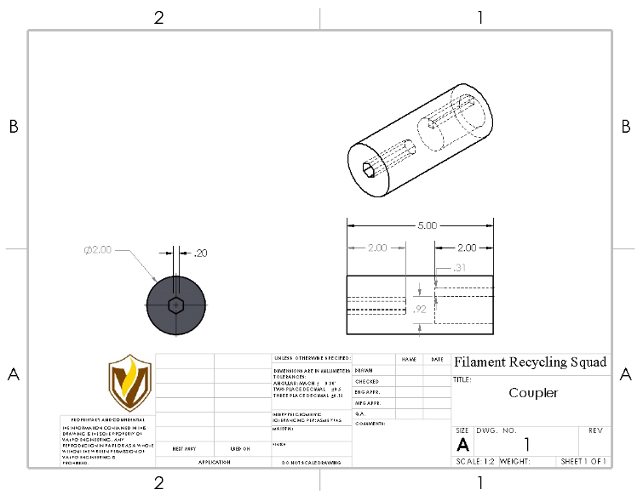**Figure 4**. Drawing for the coupler between the screw and motor shaft

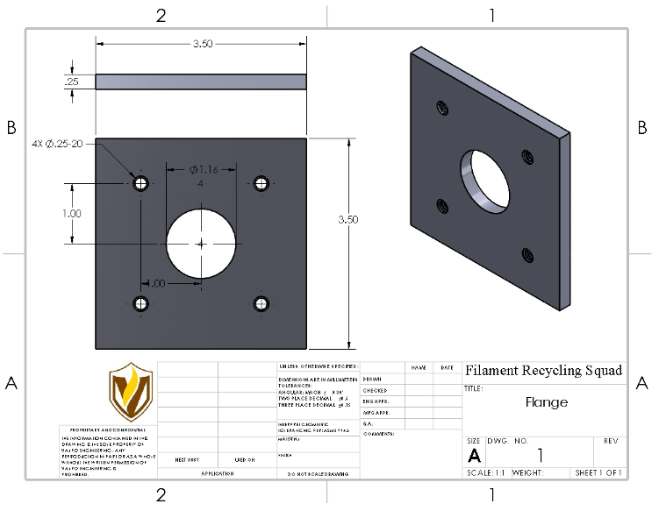

**Figure 5.** Drawing for the flange

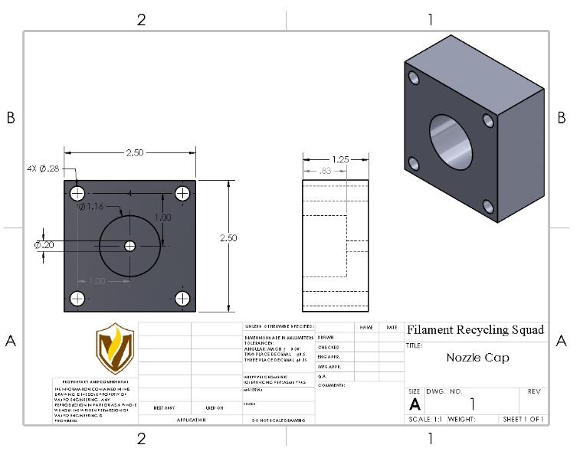

**Figure 6**. Drawing for the nozzle cap

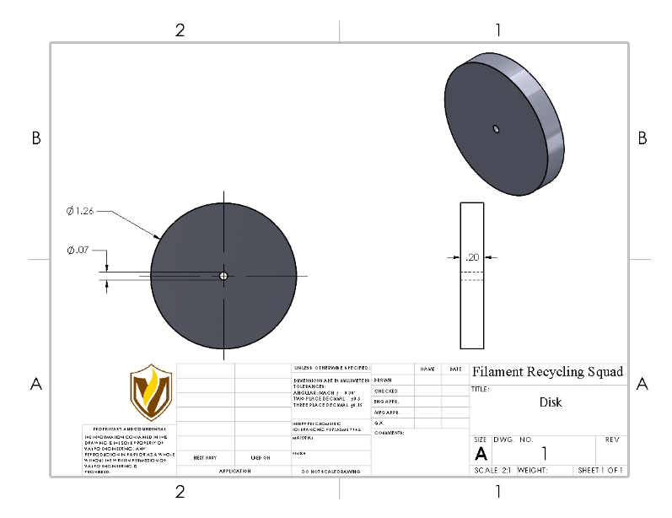

**Figure 7.** Drawing for the extrusion die

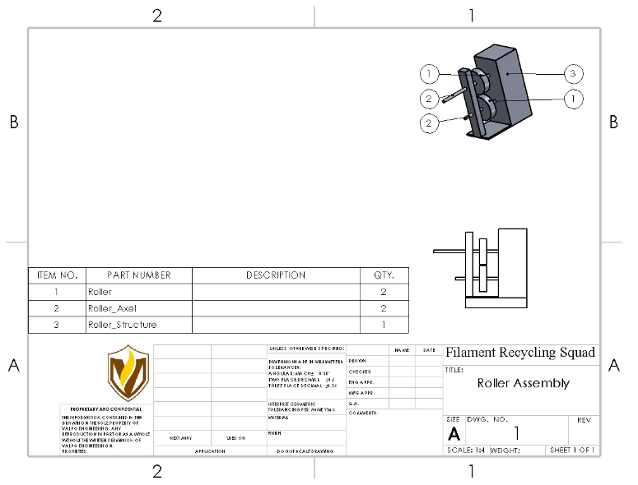

**Figure 8.** Roller assembly

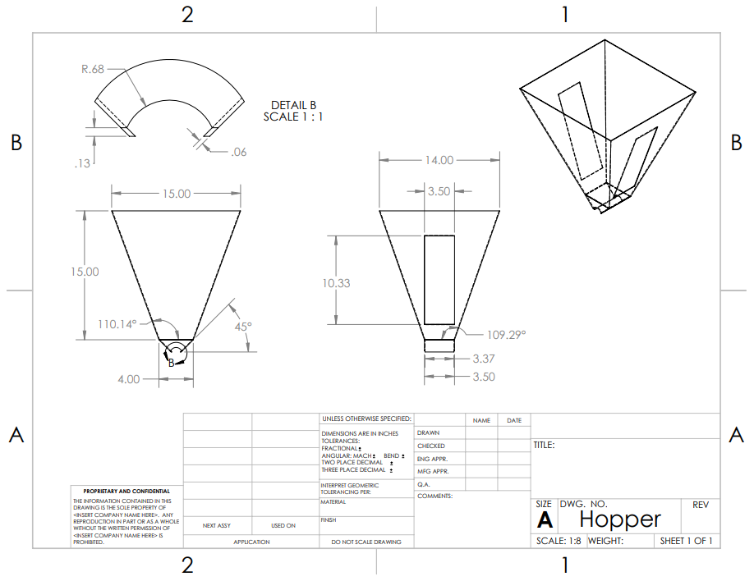

**Figure 9.** Drawing for the hopper

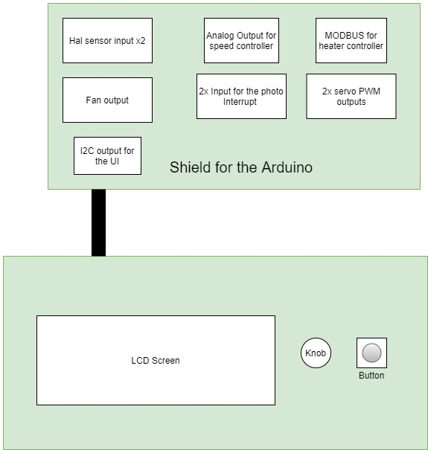

**Figure 10.** PCB layouts

**Table 1:** Bill of materials listing all components needed broken up into three main sections

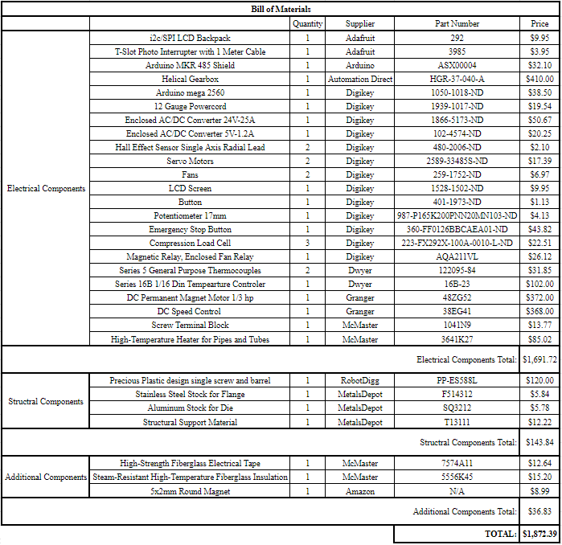

## References

**[1]** “Too Hot to Handle?,” *Johns Manville*. [Online]. Available: <https://www.jm.com/en/blog/2015/february/too-hot-to-handle/>. [Accessed: 21-Oct-2020].

**[2]** “Precious Plastic design single screw and barrel for extrusion machine,” *RobotDigg*. [Online]. Available: <https://www.robotdigg.com/product/1719/Precious-Plastic-design-single-screw-and-barrel-for-extrusion-machine>. [Accessed: 21-Oct-2020].

## Appendix A: Mechanical Drawings

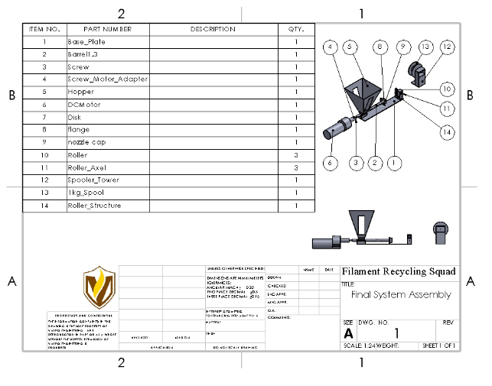

**Figure 11.** Drawing for the final system assembly

## Appendix B: Wiring Schematic

The following figure on the next page shows the connection of all the sensors, the UI and the controllers for the heater and motors. This will be incorporated into the wire organization too. For a high resolution view see here: <https://github.com/jbayert/ValpoFilamentRecycler09/blob/main/Schematic/Schematic.pdf>

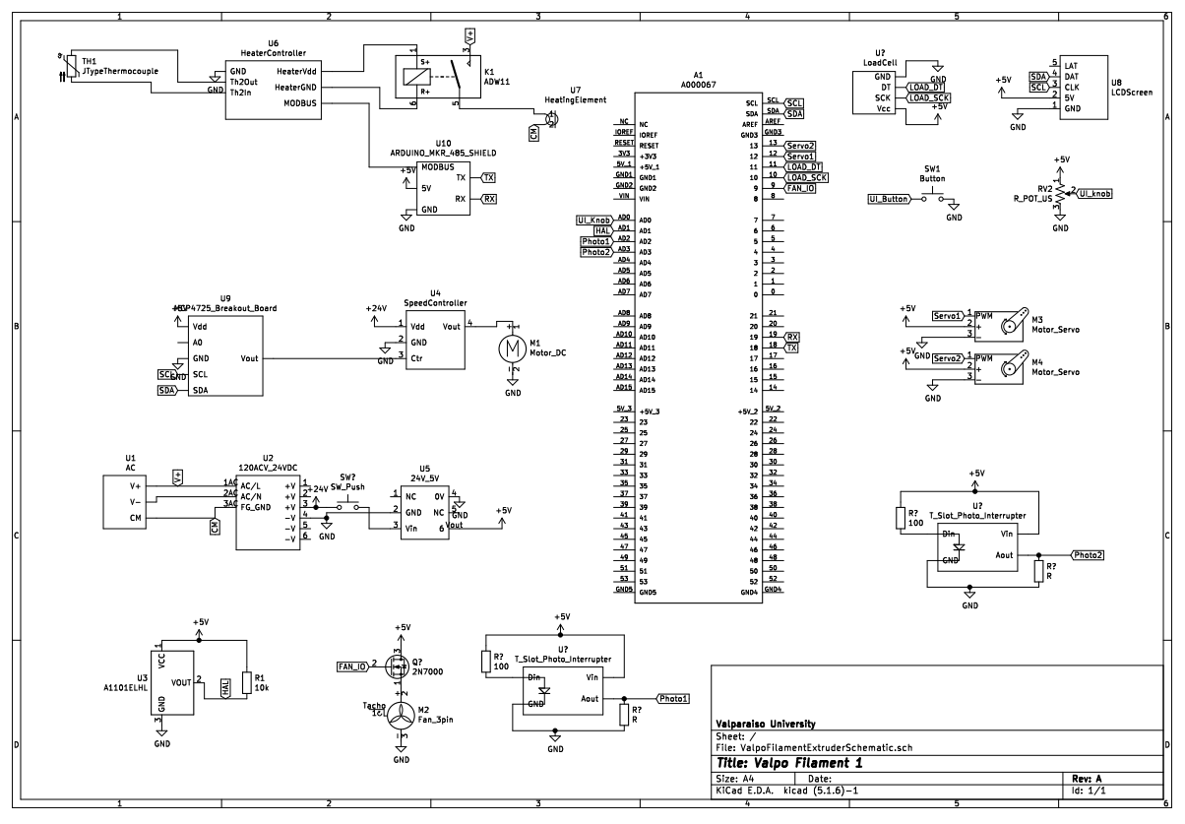

**Figure 12.** Electrical wiring schematic

## Appendix C: UI Operating Procedure

The following is a typical operating system for the operating of the UI.

